|  |  |
| --- | --- |
|  | **2013** |
|  | Dingotech  Mr Dingle |

|  |
| --- |
| **[Fun with Cars – User Manual]** |
| [Type the abstract of the document here. The abstract is typically a short summary of the contents of the document. Type the abstract of the document here. The abstract is typically a short summary of the contents of the document.] |

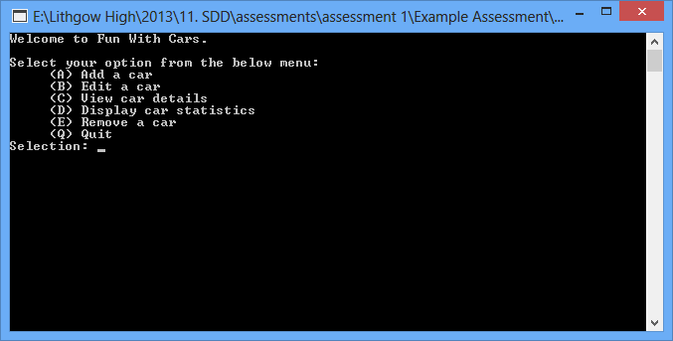

Contents

Contents

Main Menu 2

Adding a car 3

Change a car’s details 4

View a car’s details 5

Viewing all car details 6

Removing a car 7

Troubleshooting 8

# Main Menu

# Adding a car

# Change a car’s details

# View a car’s details

# Viewing all car details

# Removing a car

# Troubleshooting